Database Table Operations:
I was tasked to practice creating and dropping databases and tables.
TASK 1:
I started off with logging in to my EC2 environment.
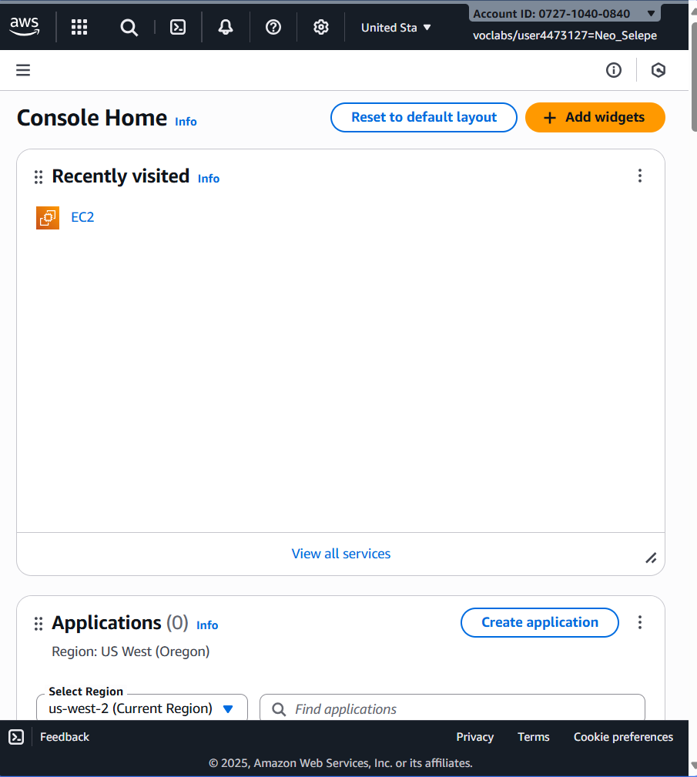

I then went to the connected instance terminal.
I configured the terminal using the following commands to connect to the relational database.
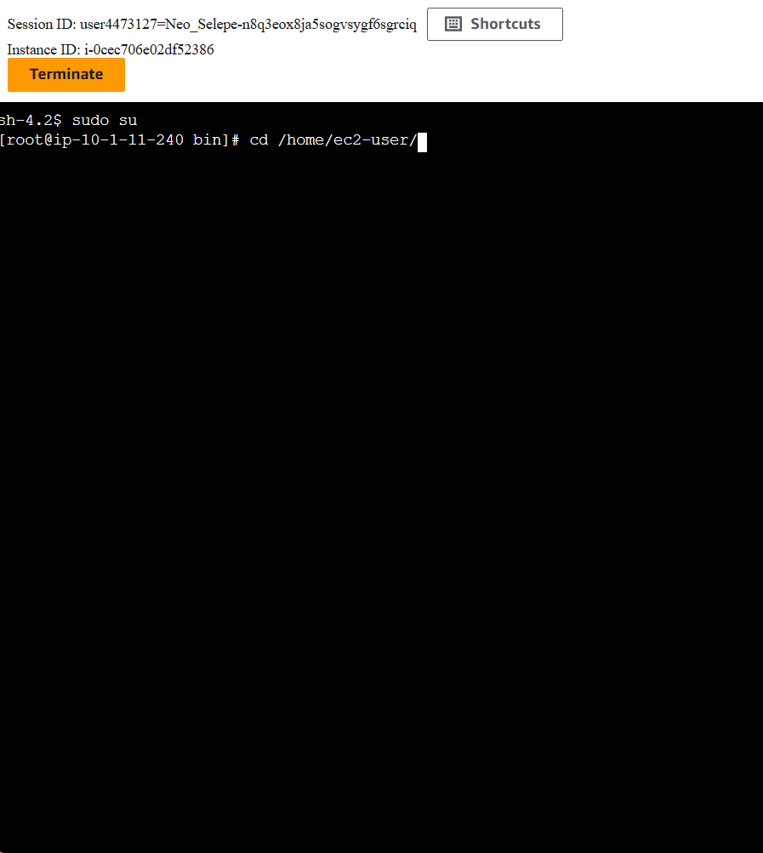

TASK 2:

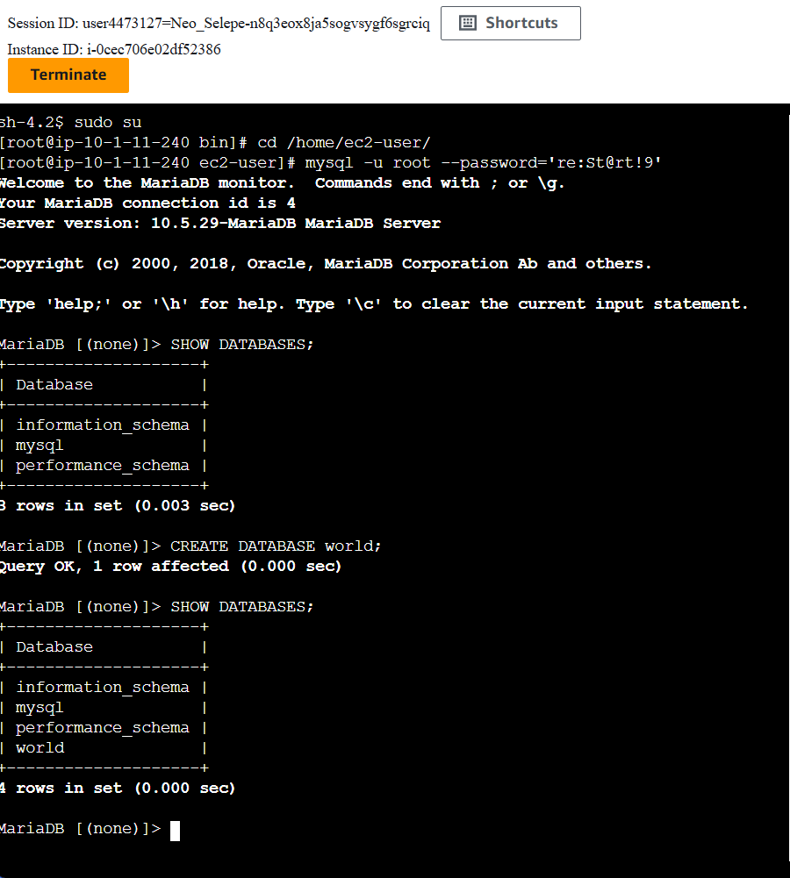
This step helped me see what databases are currently available and confirmed that I was working in the correct database instance. To verify that the world database has been successfully created, I ran the following query again.

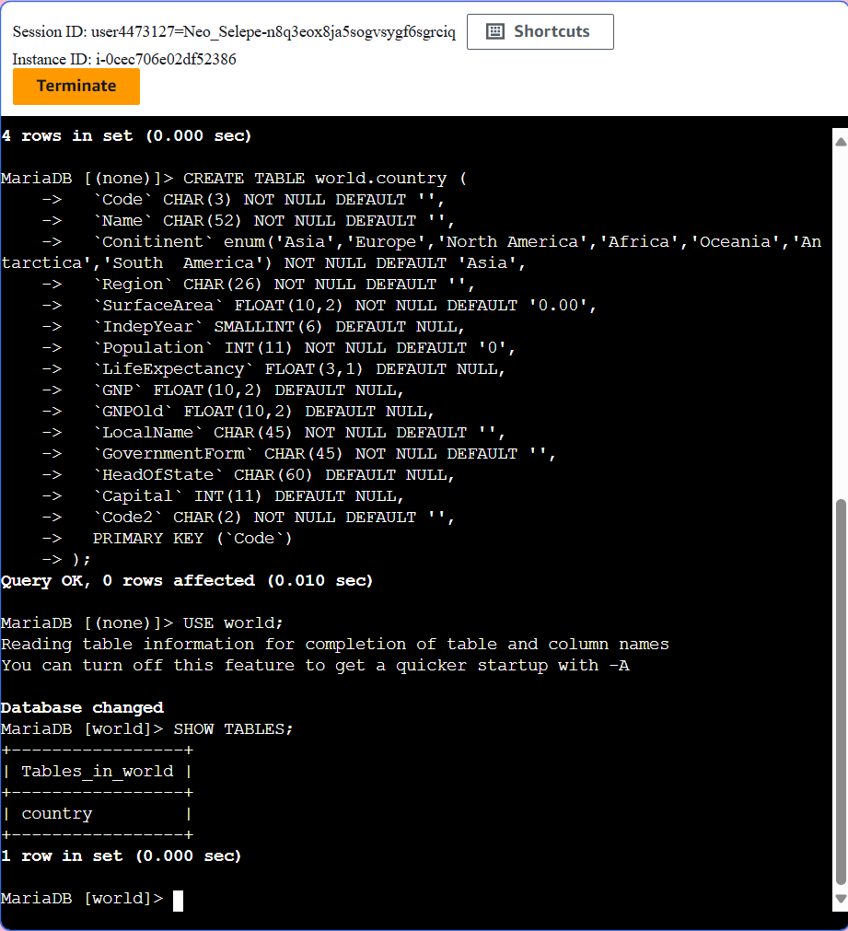
I created a table named country inside the new world database with additional information in the table, by running the CREATE TABLE command. I verified that the ‘country’ table was made by using the SHOW TABLES command.

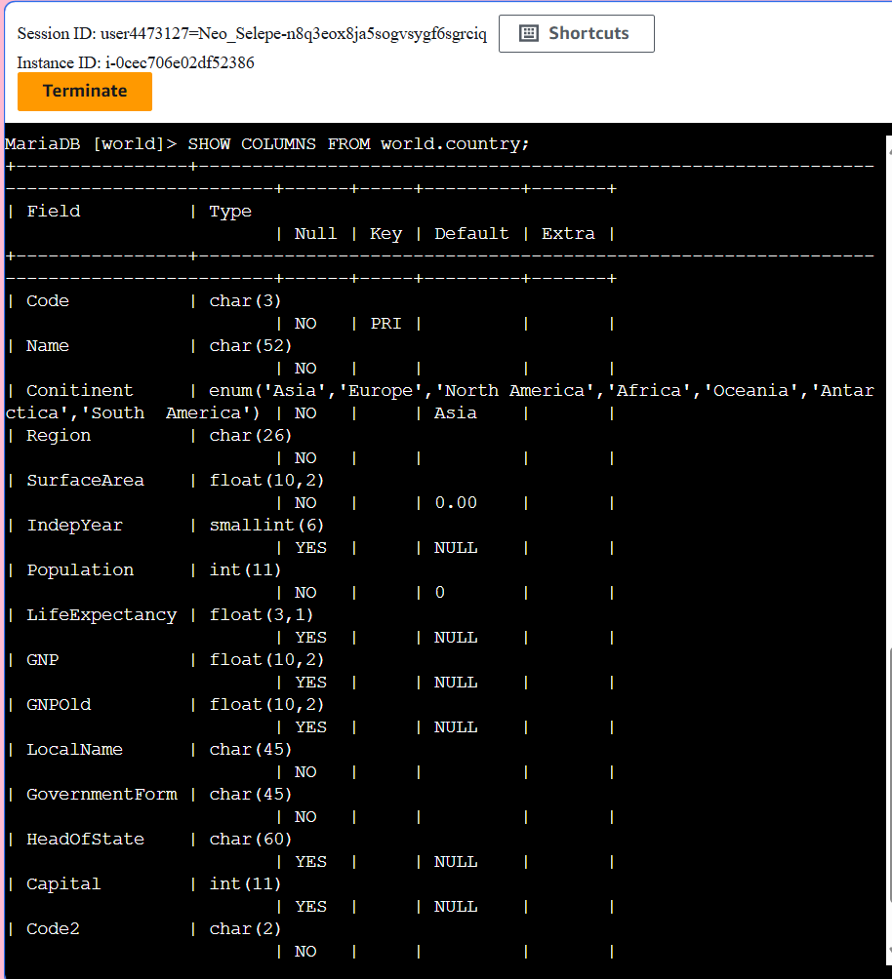
Using the SHOW COLUMS command lists all the columns on the country table which also lists their properties.

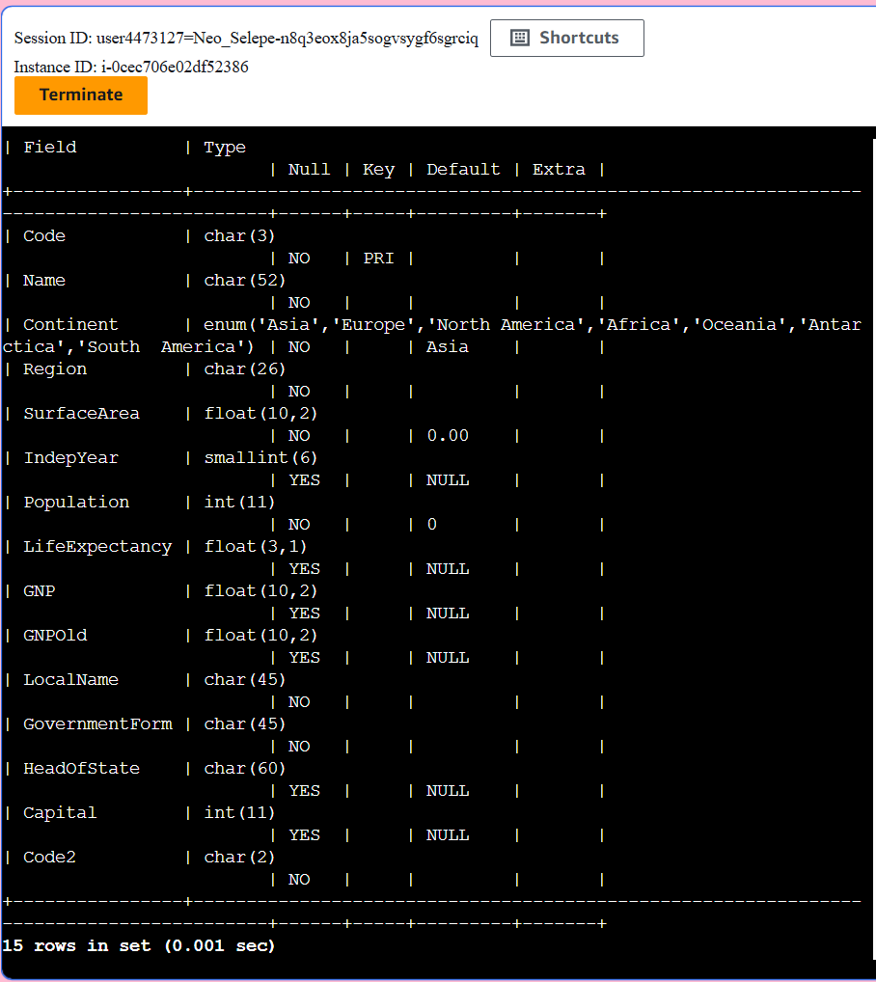
The ALTER TABLE command was used to change the incorrectly spelled ‘Continent’ column. By running the SHOW COLUMNS command, it verifies that the table has been corrected.

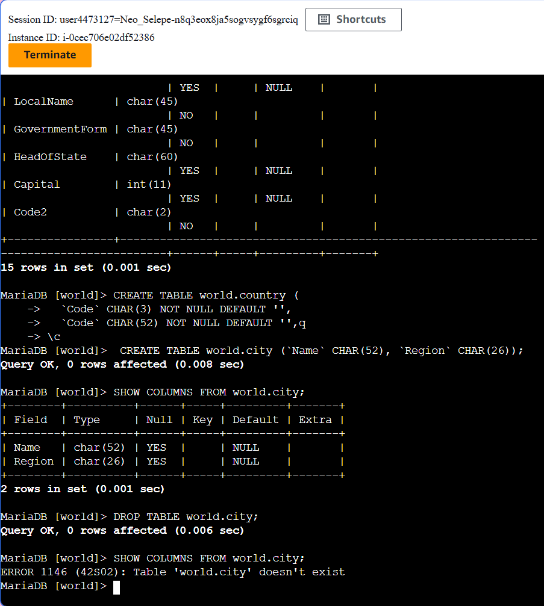
2 columns named ‘Name and Region’ where created as a challenge on a table named city and in which both column used the ‘CHAR’ data type. The table was then showed for verification of availability using the SHOW command. The DROP TABLE command was than used to delete the ‘city’ table.

This task has taught me the basic functions of interacting with a database. I learnt how to move past simply viewing data to structuring, and analysing it.

